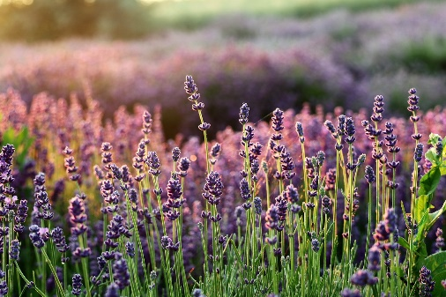Pathways & Perspectives, Wellness Workshop 6

**Icebreaker** - What smells do you like? (no right or wrong answer)

**Wellness and Stress Reduction**

1. Any thoughts on why you like those particular smells?
2. What might help LOWER stress? Focus on TWO things -

* **Fragrance (Number 3 onwards) TAKE CARE not too sniff TOO DEEPLY in case you are ALLERGIC**
* **Progressive Muscle Relaxation (PMR) gently tighten and relax every muscle in your body, start from feet, and work your way up to your head**



1. HOW are you feeling BEFORE we do the exercise?
2. Do you recognise any of these fragrances ……
3. What does this remind you of ….. do you think you know what it’s called …….
4. Are there any you particularly like …… or don’t like?
5. Time to make your OWN fragrance blend (be careful not to rub your eyes/rub any into your skin, in case the fragrance oil irritates)
6. Take some time to gently breathe in your fragrance
7. How do you feel now, compared to before?
8. Final thoughts ….

“When the petals of the heart unfold fragrance spreads across the valley.”  
― **Amit Ray**

“We choose perfumes for ourselves so we can tell the stories inside of us— the ones that we can't possibly put into words.”  
― **C. JoyBell C.**



ESSENTIAL OIL EFFECTS

1. Lavender

Lavender oil does wonders for calm seekers. It’s packed with Linalool, a natural sedative that fosters tranquillity.

1. Frankincense

 Frankincense oil calms the mind and evens out emotions. It helps you achieve a more peaceful mood and aids in stress relief.

With incensole acetate as its key player, it delivers anti-anxiety perks. Pop it in a diffuser for meditation or apply it on your temples for instant relaxation.

1. Vetiver

With its rich, earthy aroma, vetiver oil works wonders to relax the senses. It’s a natural sedative that also stabilizes your emotions.

Thanks to isovalencenol, it can make you feel less nervous. Try a few drops on a cotton ball under your pillow, or mix it with lavender oil to level up your next bath.

1. Sweet Orange

Sweet orange essential oil is your go-to for a burst of positivity and peace. Its delightful citrus aroma lifts the mood and eases anxiety.

Limonene is the key component that gives [the oil](https://www.savvyhomemade.com/fruity-perfume-with-essential-oils/) its power to diminish stress. Diffuse it in the morning for an energized yet calm start to your day, or add it to a warm bath.

1. Rose

Rose oil is the epitome of luxury—it offers comfort and emotional support when stress kicks in. It’s like a hug in a bottle that promotes positivity and eases anxiety.

1. Jasmine

Jasmine oil is all about stress relief, with a sweet scent that lifts your mood. Indole is the component in jasmine oil that provides relaxation with every breath.

1. Amber

Amber essential oil is known for its ability to **soothe anxiety symptoms, reduce stress levels, and improve overall mood**. Research has shown that inhaling amber essential oil can activate certain receptors in the brain responsible for regulating emotions. This leads to a decrease in feelings of anxiety or stress and an increase in relaxation.